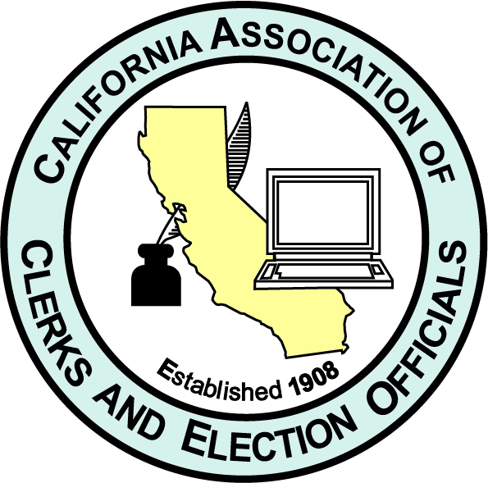
California Association of Clerks & Election Officials
113th Annual Conference
Virtual Presentation
July 12-15, 2021
Empowering Change

- VENDOR REGISTRATION -

COMPANY_________________________________________________________________________

ADDRESS_______________________________________________________________________________

CITY, STATE, ZIP_________________________________________________________________________

TELEPHONE ( ) _________________________________ E-MAIL:______________________________

CONTACT PERSON: _______________________________CONTACT PHONE #:_____________________

CONTACT E-MAIL: ____________________________________________

Vendor Fees: (circle one below)

GOLD $300 FULL PAGE AD IN CONFERENCE PROGRAM (Approx. 50 single spaced lines, that includes company logo)

SILVER $225 HALF PAGE AD IN CONFERENCE PROGRAM (Approx. 25 single spaced lines, that includes company logo)

BRONZE $175 QUARTER PAGE AD IN CONFERENCE PROGRAM (Approx. 13 single spaced lines, that includes company logo)

EMAIL REGISTRATION & COMPANY WRITEUP TO: cckeller52@gmail.com
No later than June 25th - follow up with payment – see below

LAST DAY TO CANCEL FOR REFUND: (minus $25 fee) Friday, June 25th

Please note: Refunds will not be issued after June 25, 2021. Once registered, the full registration fee is due and owing even if you are unable to attend conference; unless cancelled by June 25th deadline.

MAKE CHECK PAYABLE TO: CACEO
(Checks only, I do not have credit card capabilities)

MAIL CHECK TO: (no later than June 25th) Chrissi Keller
CACEO Conf. Coordinator
13317 34th Avenue NW
Tulalip, WA 98271
(Or Marysville, WA 98271 – both work)

QUESTIONS:
Chrissi Keller, Conference Coordinator
(360) 652-8553; Email: cckeller52@gmail.com

