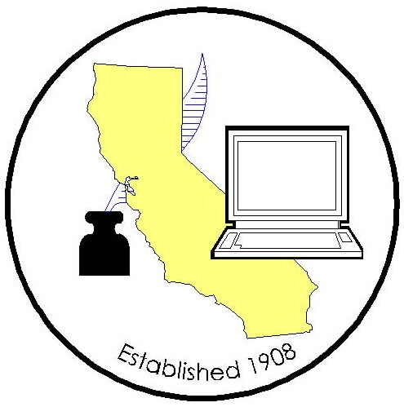

COUNTY CLERK LEGISLATIVE COMMITTEE MEETING

Meeting Date: March 25, 2021
Time: 9:30 am
Location: Teleconference

Join ZoomGov Meeting: Meeting ID: 161 277 7875

AGENDA
2020/2021 County Clerk Legislative Committee Members
Candace Grubbs, Butte |  | Joani Finwall/Melissa Garcia, San Bernardino
Elizabeth Gutierrez, Contra Costa |  | Val Wood, San Diego
Brandon Hill, Fresno |  | Teresa Williamson, San Joaquin
Chuck Storey/Victoria Wong, Imperial |  | Joe Holland/Danielle Rifilato/Melinda Greene, Santa Barbara
Kammi Foote, Inyo |  | Gina Alcomendras/Louis Chiaramonte/Belinda Gamutan, Santa Clara
Portia Sanders/Monique Blakely/Jaime Pailma, Los Angeles |  | Deva Proto/Carrie Anderson/Amanda King, Sonoma
Erik Karhu/Lisa Anderson, Riverside |  | David Valenzuela/Sheila Jetton, Ventura
Donna Allred/Andrew Graham, Sacramento
(P– Present; T– Teleconference; X– Not in attendance)

- Call to Order
- Roll Call
- Approval of Minutes (February 25, 2021)
- Legislative Advocate Update
- Bill Updates / Assignments
- AB 218 – Change of gender/marriage license
- AB 583 – Video Marriage

- Proposals
- FBN – Los Angeles

- CRAC Report
- For the Good of the Order
- Adjourned

