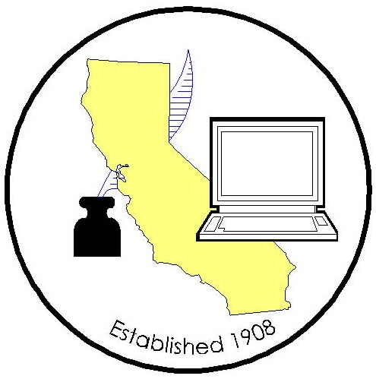

COUNTY CLERK LEGISLATIVE COMMITTEE MEETING

Meeting Date: Thursday – August 26, 2021
Time: 9:30 a.m.
Location: Teleconference

AGENDA
2020/2021 County Clerk Legislative Committee Members
Candace Grubbs/Cindi Wilde, Butte |  | Joani Finwall/Lorelay Faussier, San Bernardino
Elizabeth Gutierrez, Contra Costa |  | Val Handfield, San Diego
Brandon Hill, Fresno |  | Teresa Williamson, San Joaquin
Chuck Storey/Victoria Wong, Imperial |  | Danielle Rifilato/Melinda Greene, Santa Barbara
Portia Sanders/Monique Blakely/Jaime Pailma, Los Angeles |  | Gina Alcomendras/Louis Chiaramonte/Belinda Gamutan, Santa Clara
Lisa Anderson/Melissa Garcia, Riverside |  | Deva Proto/Carrie Anderson/Amanda King, Sonoma
Donna Allred/Andrew Graham, Sacramento |  | David Valenzuela/Sheila Jetton, Ventura
(P– Present; T– Teleconference; X– Not in attendance)

- Call to Order
- Roll Call
- Approval of Minutes (July 13, 2021)
- Legislative Advocate Update
- Bill Updates / Assignments
- AB 819 – implementation discussion
- Proposals
- Confidential Marriage Subcommittee
- CEQA Notices – San Diego
- Amend Business and Professions Code 17917 & 17924 – Los Angeles

- CRAC Report
- For the Good of the Order
- Adjournment

