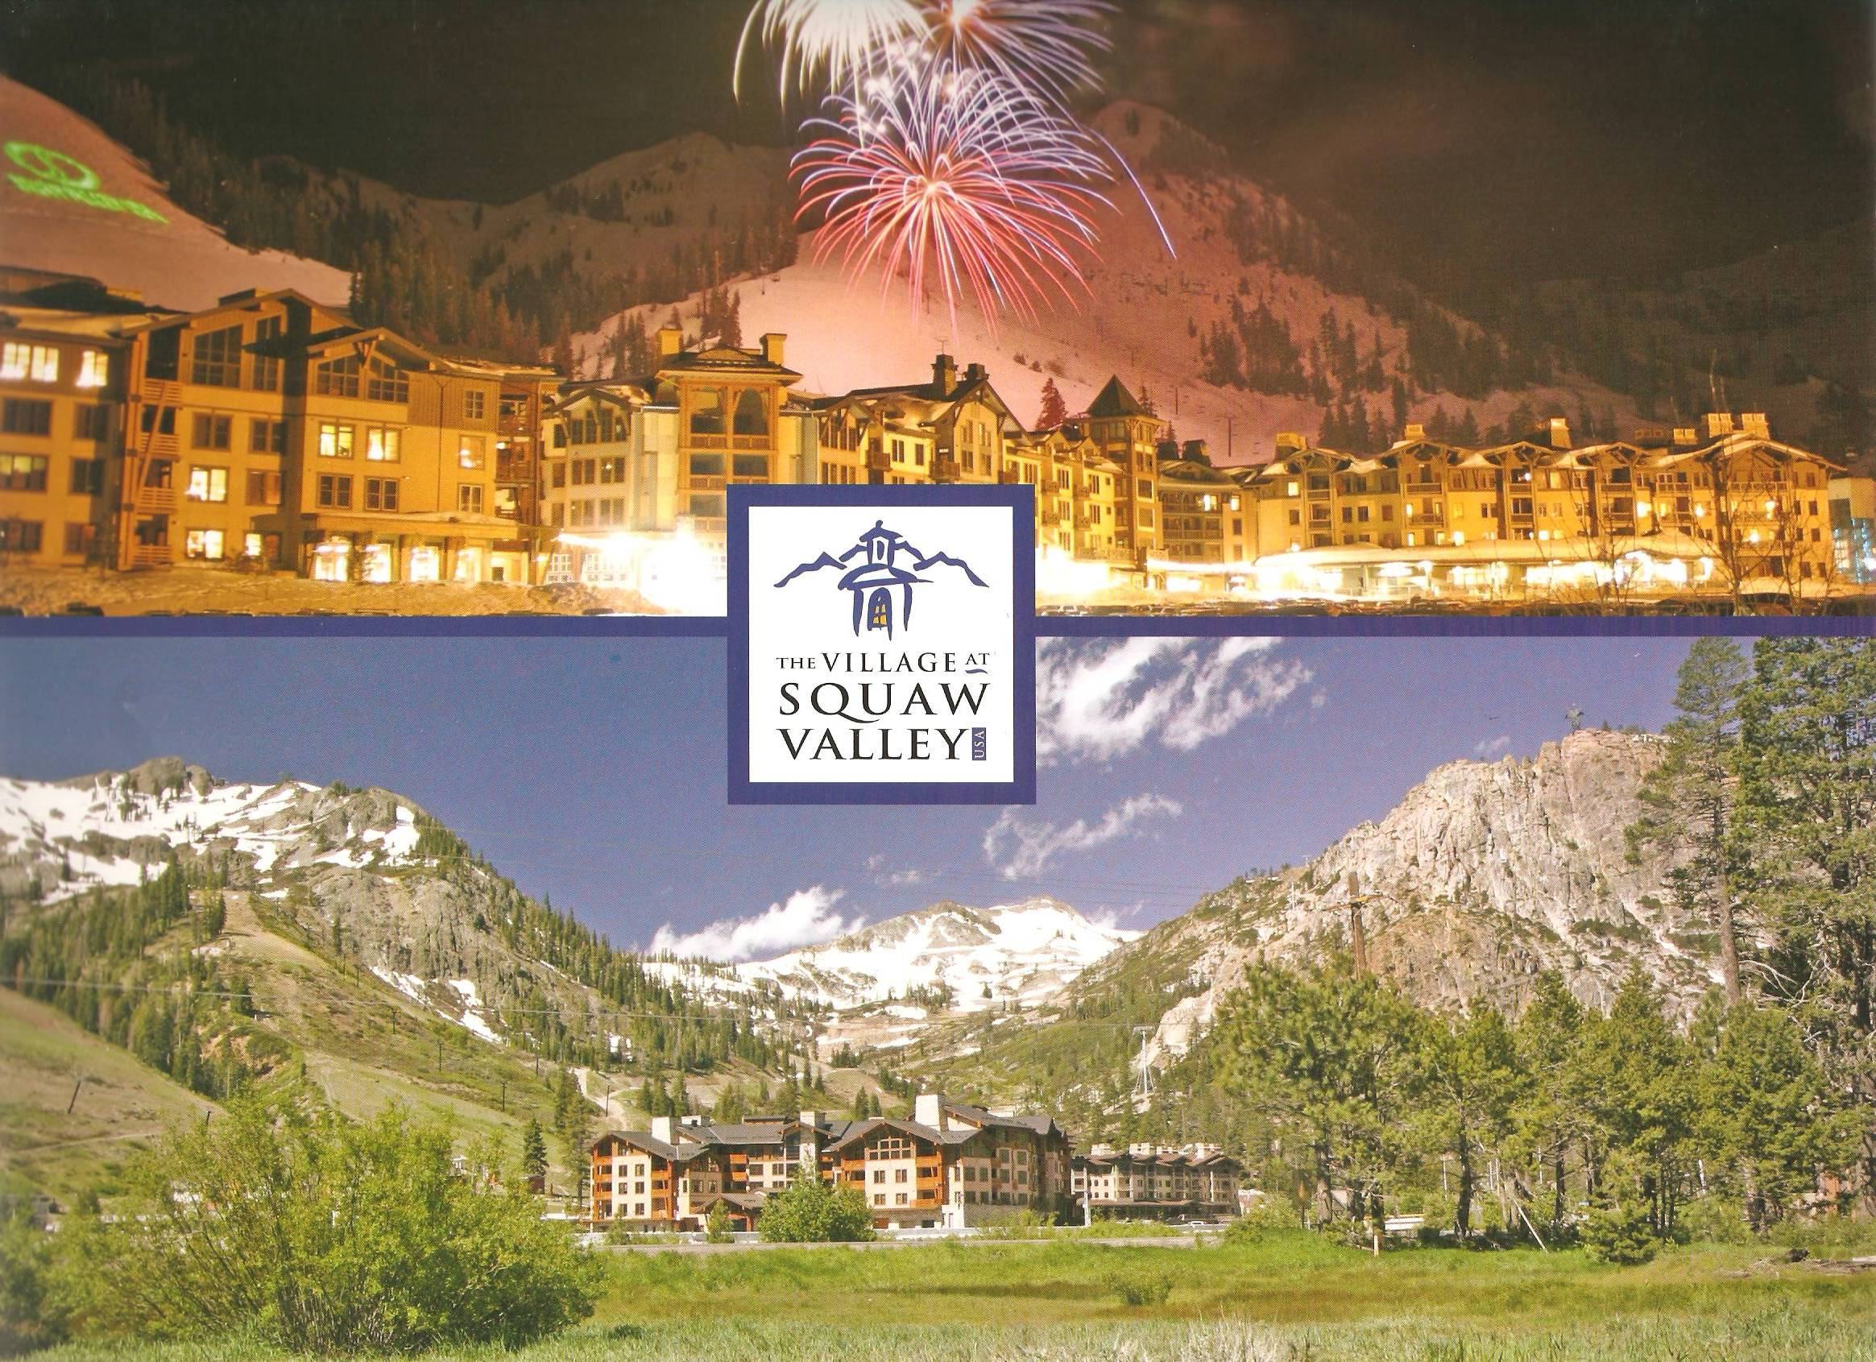

2011 CACEO ANNUAL CONFERENCE
Monday July 18 – Friday July 22, 2011
The Village at Squaw Valley USA
1750 Village East Road
Olympic Valley, CA

Adventure knows no season and luxury has no limit at the Village at Squaw Valley. It is a true all-season resort destination, where hiking, biking, rafting, horseback riding meld seamlessly into your days under the California sun.

The Village is at the base of legendary Squaw Valley USA and just 6 miles from the deepest alpine lake in North America – Lake Tahoe.

When the snow melts, Tahoe is a golfer’s paradise in the midst of stunning alpine scenery. Just minutes from the Village, Squaw Creek Championship Course was named “One of the Top 10 Courses You Can Play” by Golf Magazine.

The Village at Squaw Valley is the ultimate four-season mountain resort nestled slope side to Squaw Valley USA offering luxurious condominium suites, a first class spa, and spectacular dining and shopping. Conference Group rates will apply two days prior and two days following the conference. Mark your calendars, it will be a conference you can not miss!

