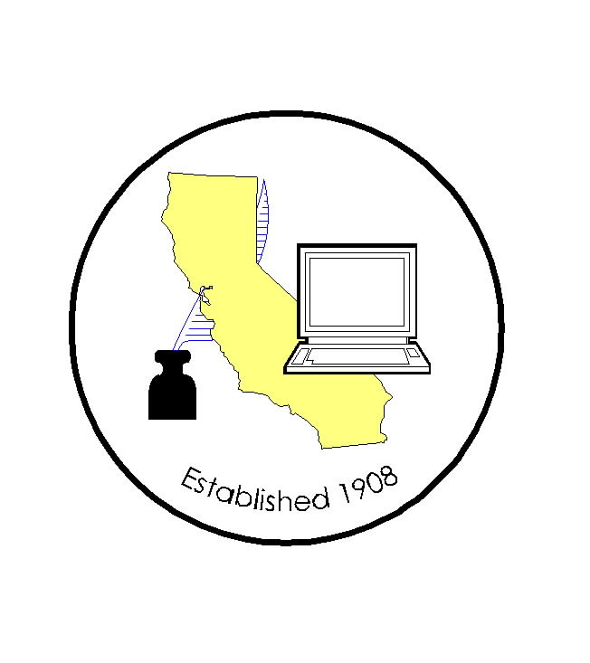
CALIFORNIA ASSOCIATION OF

CLERKS AND ELECTION OFFICIALS

March 12, 2010

TO: CACEO Members, Guests, Legislative Committee

FROM: Deborah Seiler and Jill LaVine, Co-Chairs

SUBJECT: CACEO LEGISLATIVE COMMITTEE MEETING

DATE: FRIDAY, March 19, 2010

TIME: 9:00 a.m. – 3:00 p.m.

LOCATION: Sacramento County Administration Building
700 H Street
Hearing Room One, 1st Floor
Sacramento, CA 95814

Subcommittee Meetings, Thursday, March 18

1 pm – 3 pm Voters with Specific Needs – Tim McNamara

3pm – 5 pm HAVA/Certification/Voting Systems – Tim McNamara

AGENDA

9:00 am Welcome and Introductions

Approval of Minutes of January 15, 2010 meeting

Report on EAC – Neal Kelley

Discussion of Bills Spot Bills:
AB 419 Caballero AB 2023 Saldana
AB 1676 Fuentes AB 2169 Gilmore AB 1681 Yamada SB 1366 Oropeza
AB 1689 Torres
AB 1717 (am 2/22) De Leon Senate Bills: AB 1769 Tran SB 970 Corbett
AB 1799 Fong SB 994 Price
AB 1832 Saldana SB 1102 Liu
AB 1968 Niello SB 1140 Yee
AB 1989 Mendoza SB 1203 DeSaulnier AB 2088 Adams SB 1233 Oropeza
AB 2101 (Fong - LA County) SB 1342 Simitian AB 2154 (Solorio - LA County) SB 1346 Hancock
AB 2330 Arambula SB 1404 Pavley
AB 2369 Block SB 1434 Price
AB 2371 Anderson
AB 2524 Evans
AB 2616 Hill
AB 2624 Harkey
AB 2732 Eng
ACA 2 Furutani
ACA 14 Hernandez
ACA 20 Niello
ACA 26 Calderon

11:00 am Subcommittee Proposal – Jim McCauley

Noon Lunch (on your own)

1:00 pm Subcommittee Reports

