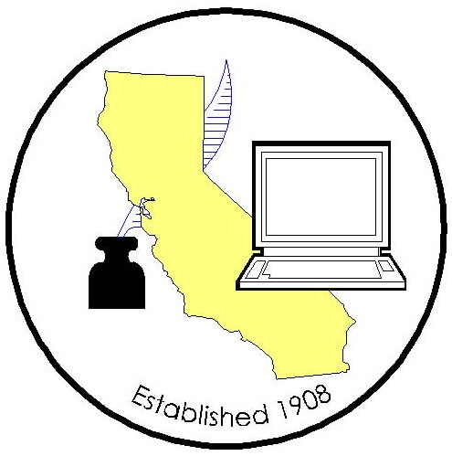
California Association of
Clerks and Election Officials

Rebecca Martinez, President
Madera County Clerk-Recorder
200 West 4th Street, Madera, CA 93637
(559) 675-7721; FAX (559) 675-7870
E-Mail: rmartinez@madera-county.com
Website: www.caceo58.org

OFFICERS 2008-2010
REBECCA MARTINEZ
PRESIDENT
Madera County
GAIL PELLERIN
VICE PRESIDENT
Santa Cruz County
CATHY DARLING
TREASURER
Shasta County
NEAL KELLEY
SECRETARY
Orange County

BOARD OF DIRECTORS
APPOINTED:
GINA ALCOMENDRAS
Santa Clara County
JANICE ATKINSON
Sonoma County
DARLENE BLOOM
Orange County
FREDERICK GARCIA
Sacramento County
JOSEPH HOLLAND
Santa Barbara County
DEAN LOGAN
Los Angeles County
KATHIE MORAN
Colusa County
DOLORES PROVENCIO
Imperial County
Susan M. RanochaK
Mendocino County
JULIE RODEWALD
San Luis Obispo County
KAY VINSON*
City Clerk, Murietta
* non-voting member
ADVISORY COUNCIL:
STEVE WEIR
Contra Costa County
ELECTED:
JULIE BUSTAMANTE
Northern Area
Lassen County
BARBARA DUNMORE
Southern Area
Riverside County
JILL LA VINE
Mother Lode Area
Sacramento County
LEE LUNDRIGAN
Central Area
Stanislaus County
LINDSEY MC WILLIAMS
Bay Area
Solano County

LEGISLATIVE COMMITTEES

CLERK OF THE BOARD:
SACHI A. HAMAI
Los Angeles County
JOHN MCKIBBEN
Los Angeles County
COUNTY CLERK:
KATHIE MORAN
Colusa County
VICKI PETERSEN
Sonoma County
ELECTIONS:
JILL LA VINE
Sacramento County
DEBORAH SEILER
San Diego County
October 10, 2008

Dr. Mark B. Horton, MD, MSPH
Director, California Department of Public Health – MS-0500
PO BOX 997377
Sacramento, California 95899-7377

Dear Dr. Horton:

On behalf of the California Association of Clerks and Election Officials, I write to express our concerns about the recent All County Letter (ACL) directing County Clerks to modify marriage license forms effective November 17, 2008.

The Department of Public Health claims it is responding to “contacts from citizens” who want to have an optional choice of designating themselves as bride or groom on the marriage form. However, the majority of the County Clerks have had no such indication from their customers. It would seem that citizens who are demanding this change would at least voice their concerns to those who issue the licenses, yet only one Clerk indicated any such concern. Interestingly, it is the same county in which a lawsuit has recently been filed over this issue.

County Clerks have no concern with the content of the change; however, the unnecessary cost to taxpayers for a form that would be in use for six weeks before being changed again is a factor, and more importantly, the timing is a major issue. We have been advised that many of our vendors that support the marriage license systems may be unable to make the appropriate changes to the programs in the timeframe provided, as they are currently working on projects mandated in AB 1168, Statutes 2007, to be completed by January 1, 2009. In addition, of the 58 County Clerks in the State, 46 are also election officials completely consumed with the conduct of the upcoming November 4, 2008 Presidential Election. To impose this change while County Clerks are preparing for the November 4, 2008 Presidential Election and for the subsequent certification of those results no later than December 2, 2008 puts a significant constraint on their ability to accomplish these mandated tasks.

While it may appear that the November 17th changes to the marriage forms are minimal, and can be accomplished reasonably quickly, that is simply not the case. With the addition of optional check boxes and new language within the margin of the forms, the entire form will need to be re-mapped. In addition, as you are aware, the law requires the County Clerk to issue a duplicate original marriage license for up to one year after the original license was issued if for any reason the original license was not registered within that time period. Due to this fact, whenever changes are made to the marriage forms, whether it’s by hard copy or an electronic marriage license system, County Clerks need to have the ability to reproduce a license issued in its original form for one year following the original license issuance date. This means the vendor cannot simply overwrite existing text within the current version of the form; they must instead create another module within the system that will allow the clerk to issue a duplicate marriage license that looks exactly like the original marriage license did when it was first issued. Current electronic marriage license systems are maintaining the framework of marriage forms used from pre-January 2008, January 2008, June 2008. The Nov. 17th change would add yet another level that the system would be required to maintain, not to mention the upcoming January 2009 forms.

County Clerks know from the previous modification to the marriage license forms that such changes require considerable effort and funds, already in short supply at the State and local level. Based on information received from 29 counties, a rough estimate of the vendor costs for this upgrade exceeds $135,000. These costs do not include increases in annual maintenance contracts which will be passed on to counties next fiscal year as a result of the number of changes made to marriage forms in the past year, nor do they include staff costs to test the system, review the forms, or working with the State to receive approval to produce the forms electronically. If the amount of time spent making the changes in June is any indication of what will be required with the proposed November 17th changes, the costs will easily exceed one million dollars statewide. Counties will file a test claim for reimbursement of their costs for these November 17th State-mandated changes.

There is no compelling reason to change the forms at this time as the forms must be changed again effective January 1, 2009. Given the serious reservations from our vendors, and in light of considerable mandated constraints at the local level, we respectfully request that this directive be modified and the changes adding the optional fields to the form be combined with the changes already mandated to go into effect January 1, 2009.

Counties are also concerned with the manner in which these changes were communicated to County Clerks and to the public. County Clerks were not consulted before the Department issued the ACL. It is clear that your staff was unaware of the substantial election and other mandated duties of county officials. Given your background with county government, it is particularly disappointing that discussion did not occur with locals about how to reasonably accomplish this change.

Of additional concern, the press spokesperson for the Department implied in news articles that couples would be able to modify existing forms to include the words “bride” and “groom” if they so desired. County Clerks were never notified of this policy change and question its appropriateness. To date, County Clerks still have not been directed by the Department how to handle such a situation. The Department would have been well-served to have engaged the county officials who provide the service at the local level as to the practical implementation of such a directive. Counties are willing to work with the State to provide workable solutions to issues; however, this recent directive has only served to foment frustration and resentment at the local level.

The California Association of Clerks and Election Officials on behalf of County Clerks urge you to reconsider this change and work to repair the relationship with the County Clerks. County Clerks are the front-line service providers and have an intimate understanding of the day-to-day operations of service to the public. Please feel free to contact me if we can offer additional assistance to that end.

Sincerely,

Rebecca Martinez, President
California Association of Clerks and Election Officials

cc: Susan Kennedy, Chief of Staff, Office of Governor Schwarzenegger
S. Kimberly Belshé, Secretary, California Health and Human Services Agency
Trina Gonzalez, Assistant Secretary, California Health and Human Services Agency
Dr. Linette Scott, MD, MPH, Deputy Director, California Department of Public Health
Richard Figueroa, Chief of Staff, Office of Governor Schwarzenegger

