DEL MONTE GOLF COURSE


Would you be interested in an evening or night golf program Tuesday July 13th?

PROGRAMS:

1. Night Golf Program: $40/person

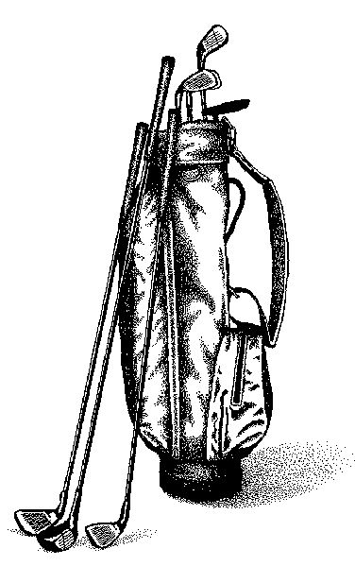
- Set up putting and chipping, games, scores, challenges
- Two pros to assist
- Approximately 1-2 hours
- Bar, at Del Monte Golf Club house
- Start after dinner, around 9 PM
- 25 people minimum

OR

2. Evening Golf Program: $20/person
(cost less as no need for lighting or separate bartender)

- Set up putting and chipping, games, scores, challenges
- Two pros to assist
- Approximately 1-2 hours
- Del Monte Golf Club house bar open
- Start after the reception, around 7:30 PM
- 25 people minimum

OR

3. Discount golf fees to play on your own July 11th – July 16th?

- - - - - - - - - - - - - - - - - - - - - - - - - - - - - - - - - - - - - - - - - - - - - - - - - - - - - - - - - - - - - - - - - - - - - - -
Yes, sign me up for:

( ) Night Golf @ $40 x ____ (payable at event)
( ) Evening Golf @ $20 x ____(payable at event)
( ) Discounts to play on my own.

NAME: _________________________________________

Please send to Chrissi Keller via FAX: (360) 652-8625 or EMAIL: cckeller52@gmail.com by June 21, 2010.

