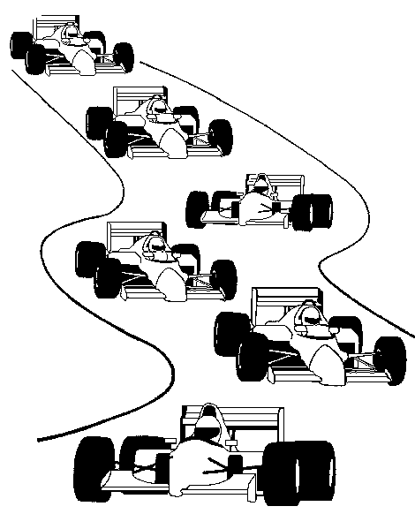
LAGUNA SECA RACEWAY
July 9 – 11, 2010

Free admission ($10 saving) with advance notice. Deadline June 28th

Spend the Day at the 2.238 – Mile World-Renowned Race Track:
Open Track: All Drivers, All Levels.

Events: Saturday: Miata Challenge, S2K Challenge & Cal Club
Corvette Challenge

Sunday: Speed Ventures is hosting the RE+FUEL Alternative Vehicle Demonstration and Sportelectric Time Trials. See tomorrow’s technologies in action today. Interact with the pioneering owners and manufacturers of alternative vehicles and see the cars and motorcycles that are at the forefront of the automotive industry’s shift to cleaner, more efficient engineering.

If you would like the chance to drive on this world famous track visit www.mazdaraceway.com for registration and fee information.

Transportation not provided.

- - - - - - - - - - - - - - - - - - - - - - - - - - - - - - - - - - - - - - - - - - - - - - - - - - - - -- - - - - - - - -
Yes! Sign me up for a day at the raceway:

NAME ________________________________________________________

# TICKETS NEEDED: __________________________________________

COUNTY NAME _______________________________________________

TELEPHONE (Contact # day of event) ________________________________

Please return to Chrissi Keller FAX: (360) 652-8625 or Email: cckeller52@gmail.com
by June 28, 2010. Questions (360) 652-8553.

