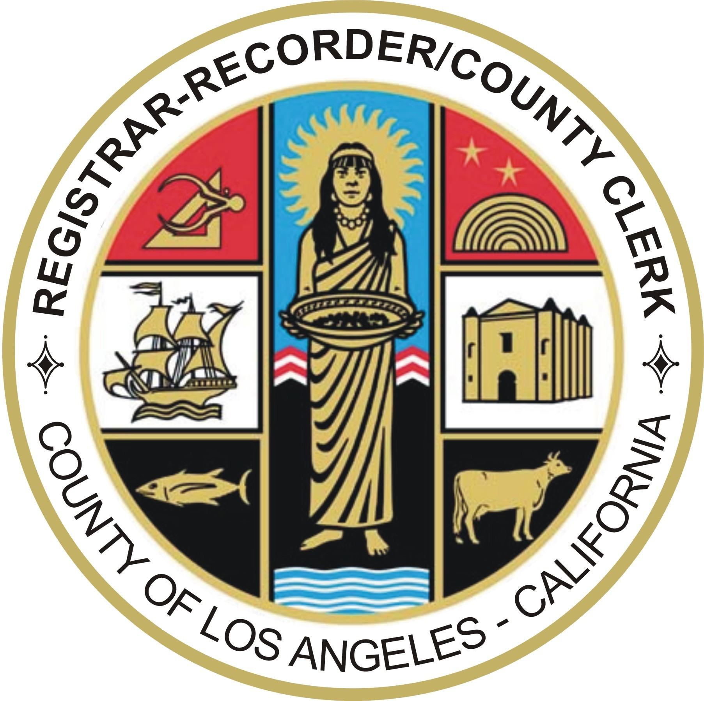

DEAN C. LOGAN
Registrar-Recorder/County Clerk
COUNTY OF LOS ANGELES
REGISTRAR-RECORDER/COUNTY CLERK
12400 IMPERIAL HWY. – P.O. BOX 1024, NORWALK, CALIFORNIA 90651-1024 – www.lavote.net

August 26, 2010

Dear Inspector:

Thank you for your service during the June 8th Statewide Direct Primary Election.

We are very proud of your performance in this election. The successful administration of elections depends on dedicated citizens such as you and you delivered. Your cooperation and adaption to polling place changes is particularly appreciated.

Please take a few minutes to complete the enclosed survey. The survey helps us identify areas we might improve upon for the next election. It gives us a good indication of how well the election equipment functioned, how our Precinct Coordinators communicated with poll workers and whether or not the Check-In Centers operated smoothly.

Again, thank you for your commitment and your hard work. I know Election Day is challenging. We look forward to your continued service.

Sincerely,

DEAN C. LOGAN
Registrar-Recorder/County Clerk

Enclosure

