How to Subscribe and Use CACEO E-Lists

The CACEO website is user maintained. It is up to you to update your profile and to subscribe or unsubscribe to the e-mail distribution lists.

At this time, these lists are available ONLY to paid members of CACEO (includes Principals, Deputies and Associates), Principals who have not paid, Life members, and our Lobbyists.

There are currently four E-Lists:

- Elecnet
- Clerknet
- Cobnet
- Principals of all disciplines

The E-lists you can subscribe to are based on your:

- Discipline (Elections, County Clerk, or Clerk of the Board of some combination) and
- Position (Principals Elist)

To subscribe or unsubscribe to an E-list, simply sign onto the website at www.caceo58.org, click on the Quick Link to the right called “Update Information About You”, and when you get to your profile page select “Edit Profile.”

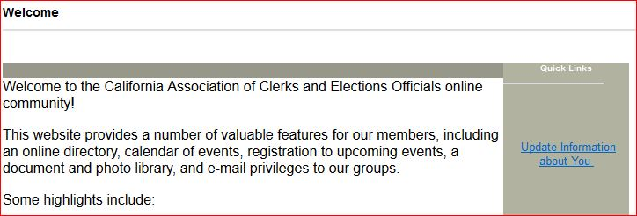
Click on “My Features” and select “E-lists.”
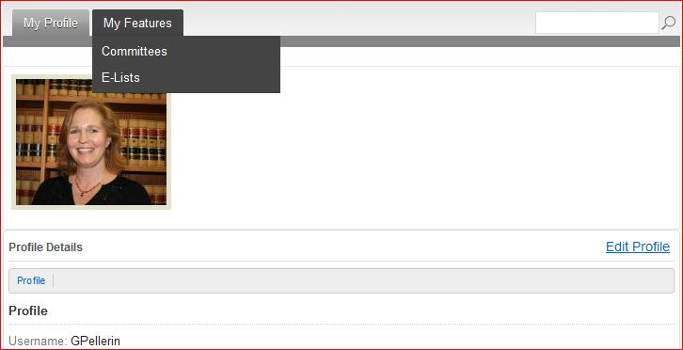
You will then go to a page that lists all the E-Lists you have access to.
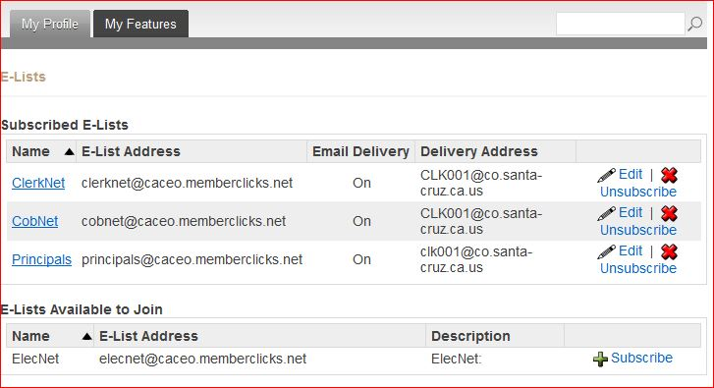
If you are already subscribed, you can edit your email address or unsubscribe.
If you are not subscribed, you can click on “Subscribe” to sign up for that E-List.
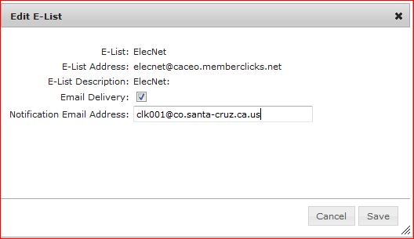
In my case, if I enter my email as gail.pellerin@co.santa-cruz.ca.us it doesn’t work. So, I use the original email I was assigned which is clk001@...
You MUST also check the Email Delivery box, and then click Save.

Once you have signed up for E-lists, you may send an e-mail to all those who are signed up for E-lists in your area of discipline by using the following addresses:
For Elections = elecnet@caceo.memberclicks.net
For County Clerk= clerknet@caceo.memberclicks.net
For Clerks of the Board = cobnet@caceo.memberclicks.net
For Principals = principals@caceo.memberclicks.net
If you have any questions, please e-mail Gail Pellerin at gail.pellerin@co.santa-cruz.ca.us Thank you.

