July 5, 2011
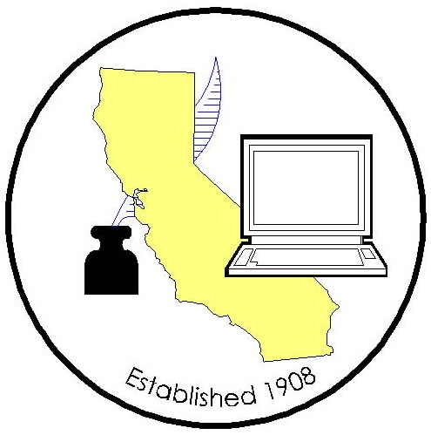
California Association of
Clerks and Election Officials

GAIL L. PELLERIN, PRESIDENT
Santa Cruz County Clerk
701 Ocean St., Room 210, CA 95060
831-454-2419 * Fax 831-454-2445 * Cell 408-316-9745
E-Mail: gail.pellerin@co.santa-cruz.ca.us
Website: www.caceo58.org

The Honorable Kristine Kehoe, Chair

Senate Appropriations Committee
State Capitol, Room 5050

Re: Assembly Bill 75 (Hill), relating to Notary Public: Solicitations
California Association of Clerks and Election Officials…SUPPORT

Dear Senator Kehoe:

The California Association of Clerks and Election Officials supports Assembly Bill 75 (Hill) which will take additional steps to address unscrupulous assessment appeal mills and request for property assessment review mills that are fraudulently advertising to California homeowners. This bill is scheduled to be heard in your Senate Appropriations Committee on Monday, July 11, 2011.

Assembly Bill 75 takes further steps to ensure consumer protection from fraudulent activities related to assessment appeals. It addresses the rampant growth of opportunistic assessment reduction filing services that offer false services for an unearned fee to unsuspecting taxpayers. During this time of rapid property value decline, AB 75 provides law enforcement with the ability to take action against these dishonest businesses who seek to prey on the vulnerable and desperate.

CACEO respectfully requests your support for AB 75.

Sincerely,

Matt Siverling
Legislative Advocate

CC: Each Member and Consultant, Senate Appropriations Committee
Assemblymember Jerry Hill

OFFICERS 2010-2012
GAIL L. PELLERIN
PRESIDENT
Santa Cruz County
CATHY DARLING ALLEN
VICE PRESIDENT
Shasta County
NEAL KELLEY
TREASURER
Orange County
DEAN LOGAN
SECRETARY
Los Angeles County

BOARD OF DIRECTORS
APPOINTED:
GINA ALCOMENDRAS
Santa Clara County
JANICE ATKINSON
Sonoma County
TESS FITZGERALD
Santa Cruz County
SACHI HAMAI
Los Angeles County
JOSEPH HOLLAND
Santa Barbara County
JIM MC CAULEY
Placer County
KATHIE MORAN
Colusa County
Susan M. RanochaK
Mendocino County
JULIE RODEWALD
San Luis Obispo County
DEBORAH SEILER
San Diego County
DAWN ABRAHAMSON*
Fremont City Clerk
* non-voting member
ADVISORY COUNCIL:
STEVE WEIR
Contra Costa County
REBECCA MARTINEZ
Madera County
ELECTED AREA CHAIRS:
JULIE BUSTAMANTE
Northern Area
Lassen County
KARI VERJIL
Southern Area
Riverside County
JILL LAVINE
Mother Lode Area
Sacramento County
AUSTIN G. ERDMAN
Central Area
San Joaquin County
LINDSEY MC WILLIAMS
Bay Area
Solano County

LEGISLATIVE COMMITTEES

CLERK OF THE BOARD:
SACHI A. HAMAI
Los Angeles County
JOHN MCKIBBEN
Los Angeles County
COUNTY CLERK:
KATHIE MORAN
Colusa County
VICKI PETERSEN
Sonoma County
ELECTIONS:
JILL LAVINE
Sacramento County
DEBORAH SEILER
San Diego County

Officium Populi – Office of the People

