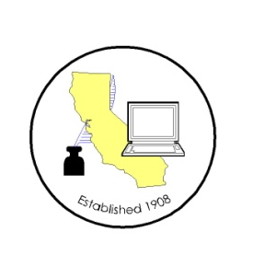
CALIFORNIA ASSOCIATION OF

CLERKS AND ELECTION OFFICIALS

DATE: January 11, 2013
TO: CACEO Members, Legislative Committee
FROM: Neal Kelley, CACEO Treasurer
SUBJECT: CACEO LEGISLATIVE COMMITTEE MEETING

DATE: FRIDAY, February 8, 2013

TIME: 9:00 a.m. – 3:00 p.m.

LOCATION: County of Sacramento DTech
799 G Street, 2nd Floor Conference Room
Sacramento, CA 95814

SUBCOMMITTEES: Thursday, February 7, 2013
(contact Subcommittee Chairs for additional information)

REGISTRATION
(Registration deadline: February 1, 2013)

Name: ____________________________________________________

County/City: ____________________________________________________

Fee enclosed: Member: $35.00 (payment received by February 1st)

$70.00 (payment received after February 1st)

Auditor cutting check

Non-Member: $105.00 (payment received by February 1st)

$155.00 (payment received after February 1st)

Check payable to: California Association of Clerks and Election Officials

Return to: Neal Kelley, CACEO Treasurer
P. O. Box 11298
Santa Ana, CA 92711-1298
phone: (714) 567-7620
fax: (714) 567-7627
e-mail: Linda.Strickland@rov.ocgov.com

